Packet Tracer – Troubleshooting EIGRP for IPv4

1. Topology

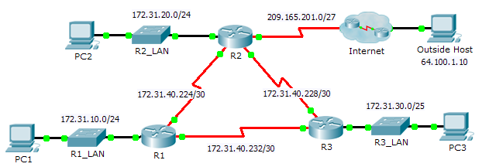

1. Addressing Table

|  |  |  |  |  |
| --- | --- | --- | --- | --- |
| Device | Interface | IP Address | Subnet Mask | Default Gateway |
| R1 | G0/0 | 172.31.10.1 | 255.255.255.0 | N/A |
| S0/0/0 | 172.31.40.225 | 255.255.255.252 | N/A |
| S0/0/1 | 172.31.40.233 | 255.255.255.252 | N/A |
| R2 | G0/0 | 172.30.20.1 | 255.255.255.0 | N/A |
| S0/0/0 | 172.31.40.226 | 255.255.255.252 | N/A |
| S0/0/1 | 172.31.40.229 | 255.255.255.252 | N/A |
| S0/1/0 | 209.165.201.1 | 255.255.255.224 | N/A |
| R3 | G0/0 | 172.31.30.1 | 255.255.255.0 | N/A |
| S0/0/0 | 172.31.40.234 | 255.255.255.252 | N/A |
| S0/0/1 | 172.31.40.230 | 255.255.255.252 | N/A |
| PC1 | NIC | 172.31.10.10 | 255.255.255.0 | 172.31.10.1 |
| PC2 | NIC | 172.31.20.10 | 255.255.255.0 | 172.31.20.1 |
| PC3 | NIC | 172.31.30.10 | 255.255.255.0 | 172.31.30.1 |

1. Scenario

In this activity, you will troubleshoot EIGRP neighbor issues. Use show commands to identify errors in the network configuration. Then, you will document the errors you discover and implement an appropriate solution. Finally, you will verify full end-to-end connectivity is restored.

1. Troubleshooting Process
2. Use testing commands to discover connectivity problems in the network and document the problem in the Documentation Table.
3. Use verification commands to discover the source of the problem and devise an appropriate solution to implement. Document the proposed solution in the Documentation Table.
4. Implement each solution one at a time and verify if the problem is resolved. Indicate the resolution status in the Documentation Table.
5. If the problem is not resolved, it may be necessary to first remove the implemented solution before returning to Step 2.
6. Once all identified problems are resolved, test for full end-to-end connectivity.
7. Documentation Table

|  |  |  |  |
| --- | --- | --- | --- |
| Device | Identified Problem | Proposed Solution | Resolved? |
|  |  |  |  |
|  |  |  |  |
|  |  |  |  |